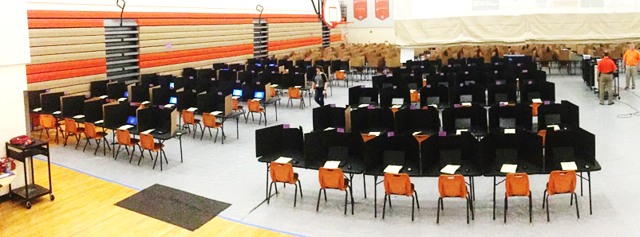
Gym Seating Chart Q2
Test: __________________Date: _______________Time: AM/PM
Session ID: ___________________Proctor 1__________________
Proctor 2______________Proctor 3 ___________________

Table |  | Table |  |  | Table |  | Table
136 | 135 | 134 | 133 |  | 132 | 131 | 130 | 129
Table |  | Table |  |  | Table |  | Table
128 | 127 | 126 | 125 |  | 124 | 123 | 122 | 121
Table |  | Table |  |  | Table |  | Table
120 | 119 | 118 | 117 |  | 116 | 115 | 114 | 113
Table |  | Table |  |  | Table |  | Table
112 | 111 | 110 | 109 |  | 108 | 107 | 106 | 105
Table |  | Table |  |  | Table |  | Table
104 | 103 | 102 | 101 |  | 100 | 99 | 98 | 97
Table |  | Table |  |  | Table |  | Table
96 | 95 | 94 | 93 |  | 92 | 91 | 90 | 89
Table |  | Table |  |  | Table |  | Table
88 | 87 | 86 | 85 |  | 84 | 83 | 82 | 81
Table |  | Table |  |  | Table |  | Table
80 | 79 | 78 | 77 |  | 76 | 75 | 74 | 73

