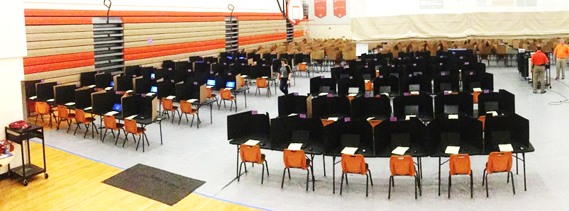
Gym Seating Chart Q3
Test: __________________Date: _______________Time: AM/PM
Session ID: ___________________Proctor 1__________________
Proctor 2______________Proctor 3 ___________________

Table |  | Table |  |  | Table |  | Table
200 | 199 | 198 | 197 |  | 196 | 195 | 194 | 193
Table |  | Table |  |  | Table |  | Table
192 | 191 | 190 | 189 |  | 188 | 187 | 186 | 185
Table |  | Table |  |  | Table |  | Table
184 | 183 | 182 | 181 |  | 180 | 179 | 178 | 177
Table |  | Table |  |  | Table |  | Table
176 | 175 | 174 | 173 |  | 172 | 171 | 170 | 169
Table |  | Table |  |  | Table |  | Table
168 | 167 | 166 | 165 |  | 164 | 163 | 162 | 161
Table |  | Table |  |  | Table |  | Table
160 | 159 | 158 | 157 |  | 156 | 155 | 154 | 153
Table |  | Table |  |  | Table |  | Table
152 | 151 | 150 | 149 |  | 148 | 147 | 146 | 145
Table |  | Table |  |  | Table |  | Table
144 | 143 | 142 | 141 |  | 140 | 139 | 138 | 137

